How to Reset Date and Time

Author: Daniel
Reviewer：Eason
Account
Issue introduction
Reset date and time
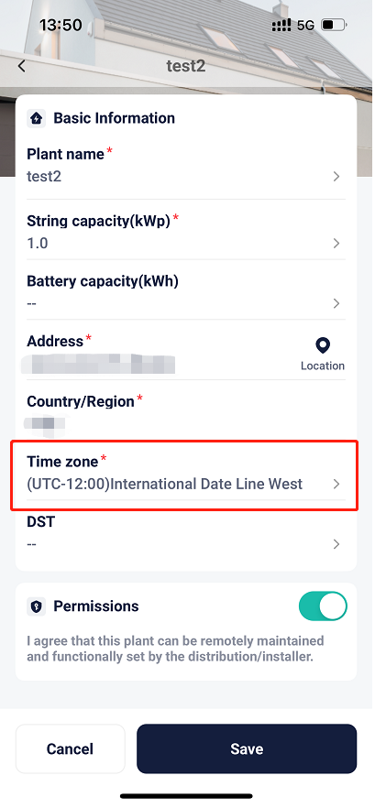
Operation guidance
Step1: Go to <Plant management> and find the station you want to change the date and time of.
Setting path：Me→Plant management→Plant
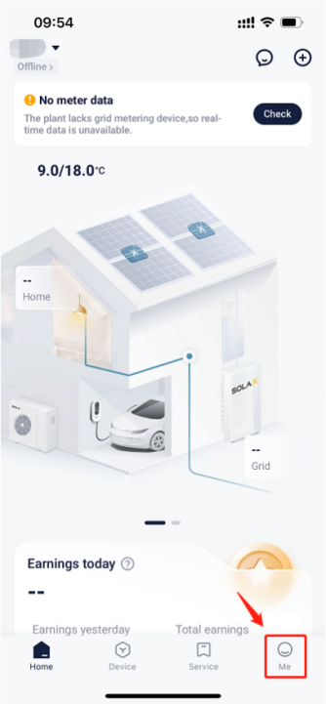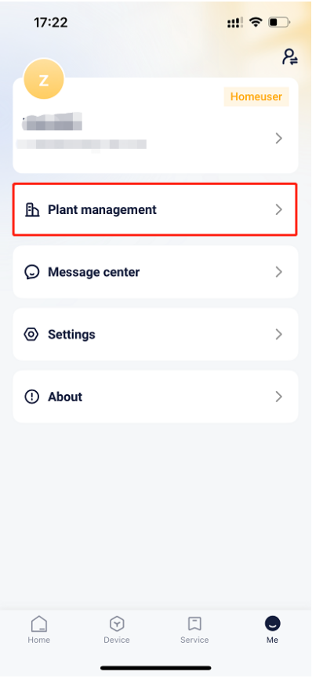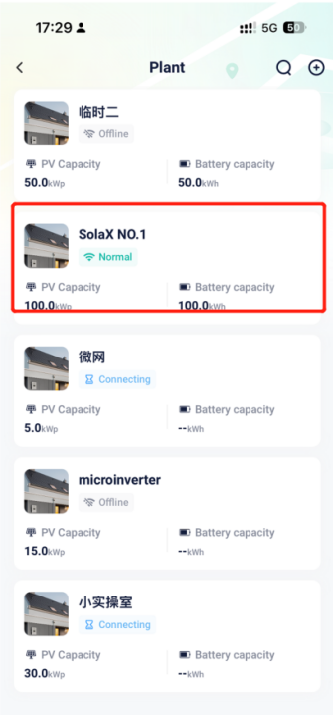
Step2：Go to <Edit plant> and change the time zone, then save the settings.
Setting path：<···>→Edit plant→Time zone→Save
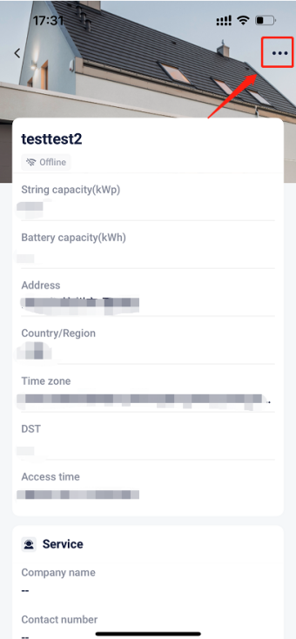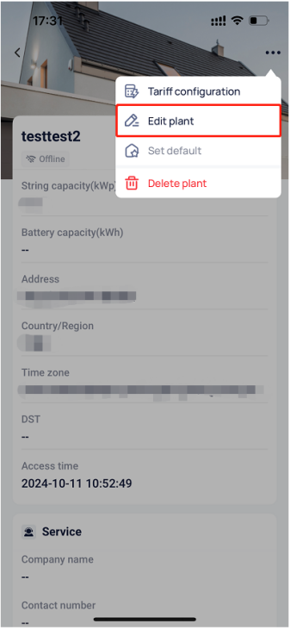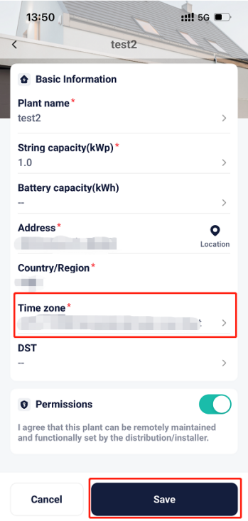
Please note
- If the setting fails, please check your mobile network, ensure a stable connection, log out of your account, and then log back in. Follow the steps above to make the changes.

